Department of Computing

School of Electrical Engineering and Computer Science

CS-250: Data Structure and Algorithms
Class: BSAI 2A

Lab 2: Pointers in C++

Date: 16th September 2026
Time: 10:00 am – 12:50 pm

Lab Instructor: Urooj Akmal

NAME : LAIBA NAEEM
CMS ID: 552001

Lab 2: Pointers in C++

Introduction
This lab is about the pointers. In C++, a pointer refers to a variable that holds the address of another variable. Like regular variables, pointers have a data type. For example, a pointer of type integer can hold the address of a variable of type integer. A pointer of character type can hold the address of a variable of character type.
Objectives
This lab will revise the old concepts taught to the students in the previous semesters.
Tools/Software Requirement
- Visual Studio C++ (or any standard C++ IDE such as Code::Blocks, CLion, or g++ compiler).
Description
Pointers are used to point towards a particular memory address. In this lab we will use the pointers and perform task with the help of them.

Lab Tasks
Task 1
Write code to find the memory in bytes occupied by int, long, double, float and char.

CODE:
#include <iostream>
using namespace std;
int main(){
cout << "Memory occupied by int: " << sizeof(int) << " byte(s)\n";
cout << "Memory occupued by double: " << sizeof(double) << " byte(s)\n" ;
cout << "Memory occupied by float: " << sizeof(float) << " byte(s)\n";
cout << "Memory occupiued by char: " << sizeof(char) << " byte(s)\n" ;
cout << "Mmemory occupied by long: " << sizeof(long) << " byte(s)\n";
}

OUTPUT:
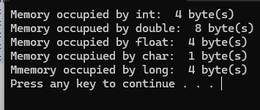
Task 2
Consider the following program and answer the questions.
void main()
{
int a, *pa; // Statement 1
pa = &a; // Statement 2
cout<<"pa = &a --> pa = "<<pa<<endl<<endl;
pa = pa + 1; // Statement 3
cout<<"pa = pa + 1 --> pa = "<<pa<<endl<<endl;
pa = pa + 3; // Statement 4
cout<<"pa = pa + 3 --> pa = "<<pa<<endl<<endl;
pa = pa - 1; // Statement 5
cout<<"pa = pa - 1 --> pa = "<<pa<<endl<<endl;
}
Output:
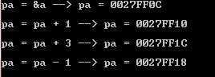
- Why does the memory address stored in pointer “pa” vary by 4?
ANSWER:
The address varies by 4 because an int takes 4 bytes on the system, so moving the pointer by 1 moves it to the next 4-byte memory location.

- Will the address still vary by 4 if the data type of the above mentioned code changed from “int” to “long”? Explain your answer.

ANSWER:
It depends on the size of long on the system.
Pointer movement is based on the size of the data type:
  - pa + 1
means:
  - address + sizeof(data type)
So if long is 8 bytes on the system, the address will increase by 8, not 4.

- If we try to multiply the address pointed to by “pa” what will happen? Is this logically or programmatically correct? Attach screen shot of the output you get when you try this multiplication.

ANSWER:
Multiplying an address is not valid because pointer arithmetic does not support multiplication. It will give a compiler error.

Task 3

int list[5]={3,6,9,12,15};
int *pArr= list;

Your task is to write a piece of code that prints all values stored in the array list using only pointer variable pArr. Do not use the conventional way of printing values by numbering indexes.

CODE:

#include <iostream>
using namespace std;
int main(){
int list[5] = { 3, 6, 9, 12, 15 };
int *pArr = list;

for (int i = 0; i < 5; i++){
cout << *(pArr + i) << " ";
}
return 0;
}
OUTPUT:
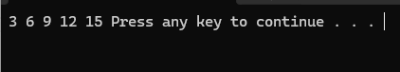

Task 4
Write output of the following C++ codes in your document without executing it.
Example code a)
int x[4] = {0,4,6,9};
int *p, a=3;
p=x;
(*p)++;
cout<<*p<<endl;
cout<<*(p+1)<<endl;
p++;
*p=*p+a;
cout<<*p<<endl;
p=p+2; //What is happening here?
cout<<*p<<endl;

Output:
1
4
7
9

Example code b)
int a, *p, *q;
int arr[4]= {0};

p=arr;
q=p;

*p=4;

for(int i=0; i<3; i++){
a=*p;
p++;
*p=(a+i);
}
for (int j=0; j<4; j++){
cout<<*q<<" ";
q++;

}

Output:
4
4
5
7

Task 5

int a=5, b=10;
int *pa=&a; //pa and pb are pointer variables of type int.
int *pb=&b;

int **ppa=&pa; //ppa and ppb are called double pointers or pointers-to-pointers.
int **ppb=&pb;

- Write code of a function that swaps values of variables a and b. Input to the function should be the address of both the variables.

CODE:
#include <iostream>
using namespace std;

void swap(int *x, int *y)
{
int temp;
temp = *x;
*x = *y;
*y = temp;

}

int main(){
int a = 5, b = 10;
int *pa = &a;
int *pb = &b;

int **ppa = &pa;
int **ppb = &pb;

swap(&a, &b);

cout << "a = " << a << endl;
cout << "b = " << b << endl;
return 0;
}

OUTPUT:

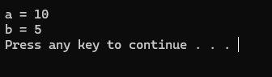
- Write code of a function that swaps values of the variables a and b using pointer-to-pointer variables ppa and ppb.

CODE:
#include <iostream>
using namespace std;

void swap(int **x, int **y)
{
int temp;

temp = **x;
**x = **y;
**y = temp;
}

int main(){
int a = 5, b = 10;
int *pa = &a;
int *pb = &b;

int **ppa = &pa;
int **ppb = &pb;

swap(&pa, &pb);

cout << "a = " << a << endl;
cout << "b = " << b << endl;
return 0;
}

OUTPUT:
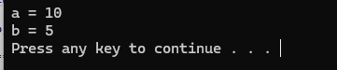

Task 6

- A teacher records marks for a group whose number of students and number of subjects are entered at runtime. Each row represents a student and each column a subject.
- Read and validate rows and cols before allocation. Allocate an int** marks array of row pointers, then allocate cols integers for each row.
- Read marks from 0 to 100 and display the matrix. Assume entered marks are valid. Use *(*(marks + r) + c) in at least one complete input or output loop.
- Calculate each student’s total. Display the student with the highest total and that total. If totals tie, report the first student. Use student numbers starting at 1.
- Delete all rows, then delete the row-pointer array and set marks to nullptr. Explain what would remain allocated if only delete[] marks; were executed.
- For two students and three subjects, sketch the pointer variable, the array of two row pointers and the two separately allocated rows. Label marks, marks[0] and marks[0][0].
Hint: determine the first student’s total before comparing other students. Keep separate variables for the best total and its student number.

Input by row | Expected result
2 × 3: 50 60 70 / 80 40 90 | Totals: 180, 210; top student: 2
2 × 2: 40 60 / 50 50 | Totals: 100, 100; top student: 1
1 × 1: 75 | Total: 75; top student: 1

CODE:

#include <iostream>
using namespace std;

int main()
{
int rows, cols;

do
{
cout << "Enter number of students: ";
cin >> rows;

if (rows <= 0)
{
cout << "Number of students must be greater than 0.\n";
}

} while (rows <= 0);

do
{
cout << "Enter number of subjects: ";
cin >> cols;

if (cols <= 0)
{
cout << "Number of subjects must be greater than 0.\n";
}

} while (cols <= 0);

int** marks = new int*[rows];

for (int r = 0; r < rows; r++)
{
*(marks + r) = new int[cols];
}

cout << "\nEnter marks (0 to 100):\n";

for (int r = 0; r < rows; r++)
{
for (int c = 0; c < cols; c++)
{
do
{
cout << "Student " << r + 1
<< ", Subject " << c + 1 << ": ";

cin >> *(*(marks + r) + c);

if (*(*(marks + r) + c) < 0 ||
*(*(marks + r) + c) > 100)
{
cout << "Invalid marks! Enter a value "
<< "between 0 and 100.\n";
}

} while (*(*(marks + r) + c) < 0 ||
*(*(marks + r) + c) > 100);
}
}

cout << "\nMarks Matrix:\n";

for (int r = 0; r < rows; r++)
{
cout << "Student " << r + 1 << ": ";

for (int c = 0; c < cols; c++)
{
cout << *(*(marks + r) + c) << "\t";
}

cout << endl;
}

int bestTotal = 0;

for (int c = 0; c < cols; c++)
{
bestTotal += *(*(marks + 0) + c);
}

int bestStudent = 1;

for (int r = 1; r < rows; r++)
{
int total = 0;

for (int c = 0; c < cols; c++)
{
total += *(*(marks + r) + c);
}

if (total > bestTotal)
{
bestTotal = total;
bestStudent = r + 1;
}
}

cout << "\nStudent with highest total: "
<< bestStudent << endl;

cout << "Highest total: "
<< bestTotal << endl;

for (int r = 0; r < rows; r++)
{
delete[] * (marks + r);
}

delete[] marks;

marks = nullptr;

return 0;
}

OUTPUT:
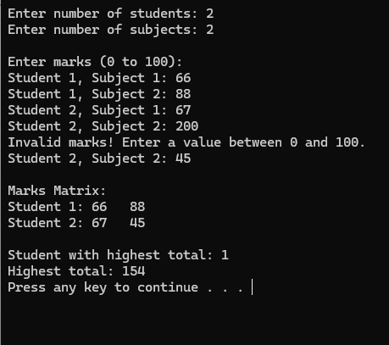
Task 7
A new student joins after the marks have been entered. Write a separate program that reads n (1–10), allocates n marks and then stores one additional mark.
1. Allocate a second block of n + 1 integers. Copy the original n values into it using pointer notation. Read the new mark into the final position.
2. Release the old block. Make the original pointer refer to the new block, update the stored size, and display all values.
3. Release the final block exactly once. Explain why changing n alone does not increase the old block’s capacity.
Check: n = 3; marks 45 60 75; new mark 90 → 45 60 75 90. Also test n = 1; mark 0; new mark 100 → 0 100.
Hint: allocate → copy → append → delete old block → update pointer and size. Other pointers to the old block then become dangling.

CODE:

#include <iostream>
using namespace std;

int main()
{
int n;

do
{
cout << "Enter number of marks (1-10): ";
cin >> n;

if (n < 1 || n > 10)
{
cout << "Invalid input. Enter n between 1 and 10.\n";
}

} while (n < 1 || n > 10);

int* marks = new int[n];

cout << "Enter " << n << " marks:\n";

for (int i = 0; i < n; i++)
{
cin >> *(marks + i);
}

int* newMarks = new int[n + 1];

for (int i = 0; i < n; i++)
{
*(newMarks + i) = *(marks + i);
}

cout << "Enter new student's mark: ";
cin >> *(newMarks + n);

delete[] marks;

marks = newMarks;

n = n + 1;

cout << "\nAll marks:\n";

for (int i = 0; i < n; i++)
{
cout << *(marks + i) << " ";
}

cout << endl;

delete[] marks;
marks = nullptr;

return 0;
}

OUTPUT:

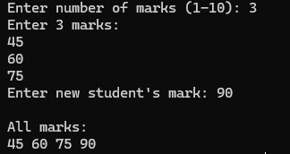
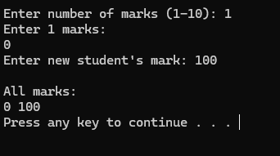
Task 8

The following fragment is intended to read and display three integers. Inspect it before running it; its current behaviour is undefined.
int n = 3;
int* values = new int[n];
for (int i = 0; i <= n; i++)
cin >> values[i];
delete values;
cout << values[0];
- Identify three errors. For each, state the problem and explain its consequence.

Error 1: Out-of-bounds access
The loop is:
for (int i = 0; i <= n; i++)
Since n = 3, the valid indexes are:
0, 1, 2
But i <= n allows:
i = 0, 1, 2, 3
So this statement:
cin >> values[i];
tries to access values[3], which is outside the allocated array.
The correct condition is:
i < n

Error 2: Incorrect delete
The memory was allocated using:
new int[n]
Therefore, it must be released using:
delete[] values;
not:
delete values;
Using the wrong form of delete causes undefined behavior.

Error 3: Using a dangling pointer
After:
delete[] values;
the memory is released, so values no longer points to a valid allocated array.
But the original code does:
cout << values[0];
after deleting the memory.
That means it is trying to access freed memory—a dangling pointer access.
You should set the pointer to nullptr after deleting it:
delete[] values;
values = nullptr;
And display the values before deleting the array.

- Write a corrected complete program that reads and displays all three integers, releases the allocation correctly and resets the pointer. Test with 4 5 6.

CODE:

#include <iostream>
using namespace std;

int main()
{
int n = 3;

int* values = new int[n];

for (int i = 0; i < n; i++)
{
cin >> values[i];
}

cout << "Values: ";

for (int i = 0; i < n; i++)
{
cout << values[i] << " ";
}

cout << endl;

delete[] values;

values = nullptr;

return 0;
}
OUTPUT:

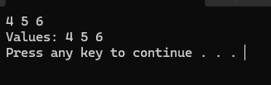
Briefly distinguish an out-of-bounds access, a dangling pointer and a memory leak. Explain why a program appearing to run successfully does not prove its memory accesses are valid.

- Out-of-bounds access: Trying to access memory outside the allocated array, such as values[3] when only values[0] through values[2] exist.
- Dangling pointer: A pointer that still contains the address of memory that has already been released. For example, using values after delete[] values.
- Memory leak: Allocated memory is never released, so the program loses the ability to free it.
For example:
  - int* p = new int[3];
  - // forgot to delete[] p
This creates a memory leak.
Finally, a program appearing to work correctly doesn't prove the memory access is valid. Undefined behavior can sometimes produce the expected output by chance, but it can also produce incorrect results or crash depending on the compiler, operating system, memory layout, or what happens to be stored in that memory.

Deliverables
Compile a single word document by filling in the solution part and submit this Word file on LMS. The name of word document should follow this format. i.e. YourFullName(reg)_Lab#. You must show the implementation of the tasks in a complete Word document to get your work graded. You must also submit this Word document on the LMS.
Note: Students are required to upload the lab on LMS before deadline.
Use proper indentation and comments. Lack of comments and indentation will result in deduction of marks.

Lab Rubrics
Assessment | Doesn’t meet Expectation  (1-2) | Meets Expectation  (3-4) | Exceeds Expectation  (5) | Marks
Software Problem Realization  (CLO2 – PLO2) | The Student is unable to understand and outline the problem and doesn’t use the relevant method to solve it. | The student requires some guidance to completely comprehend the problem and to differentiate the data structure and algorithm comprehensively. | The student fully understands the given problem, is able to analyze the relevant method to solve it, and develops a detailed program flow.
Software Tool Usage  (CLO3 – PLO5) | The student has no idea on how to use the basic tools of the software. The codes have syntax errors, and parts of the codes are missing. Also, they are unable to imitate the required output | The student has a limited command on the basic tools of the software and operated it under supervision. The codes are correct in terms of their syntax, however, the program output is not always correct. | The student has full command on various tools available in the software. Furthermore, his/her coding is complete and functional, and the program output is correct. Moreover, they can easily manipulate the code to design a particular solution
Ethics and Adherence to Laboratory Safety Rules  (CLO4 - PLO 8) | The student does not behave according to the professional ethics by following ethical norms applicable to the software industry such as acknowledgement while using publicly available data/ code. Disturbs the lab environment, doesn’t take care of safety measures, and/or isn’t punctual. | The student partially demonstrate their commitment to professional ethics by following ethical norms applicable to the software industry such as referencing and acknowledgement while using publicly available data/ code. Exhibits better behavior, works by taking into account the safety measures, and is punctual. | The student clearly express the commitment to professional ethics by following ethical norms applicable to the software industry such as referencing and acknowledgement while using publicly available data/ code. Encourages others to maintain lab decorum, and alerts them to follow safety measures.

